**The Recording Process**

**Summary of Debit/Credit Rules:**

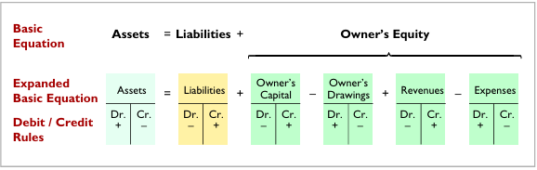

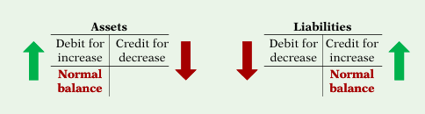 

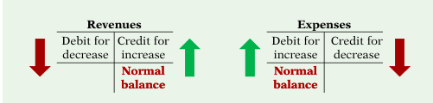 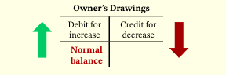

**Transactions of Pioneer Advertising**

1.On October 1, C. R. Byrd invests $10,000 cash in an advertising company called Pioneer Advertising.

2. On October 1, Pioneer purchases office equipment costing $5,000 by signing a 3-month, 12%, $5,000 note payable.

3. On October 2, Pioneer receives a $1,200 cash advance from R. Knox, a client, for advertising services that are expected to be completed by December 31.

4. On October 3, Pioneer pays office rent for October in cash, $900.

5. On October 4, Pioneer pays $600 for a one-year insurance policy that will expire next year on September 30.

6. On October 5, Pioneer purchases an estimated 3-month supply of advertising materials on account from Aero Supply for $2,500.

7. On October 20, Pioneer receives $10,000 in cash from Copa Company for advertising services performed in October.

8. On October 26, Pioneer owes employee salaries of $4,000 and pays them in cash.

9. On October 31, C. R. Byrd withdraws $500 cash for personal use.

**Journal**

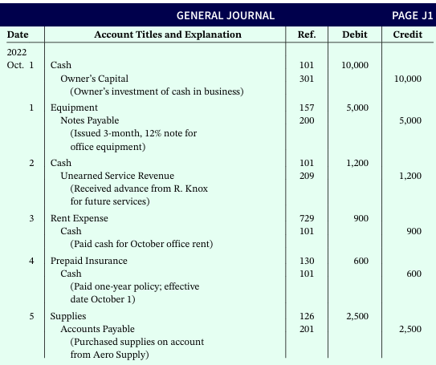

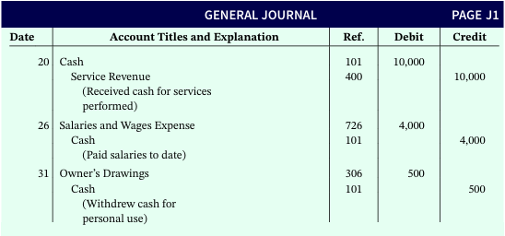

**Ledger**

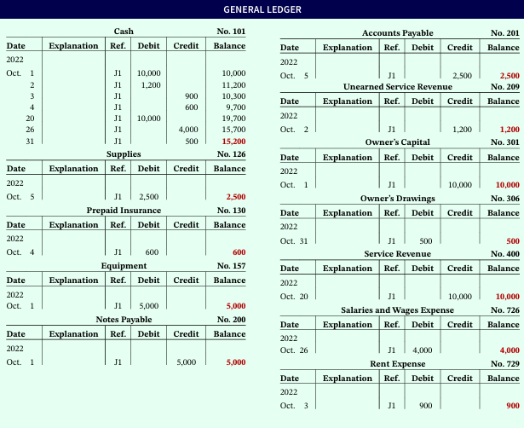

**Trial Balance**

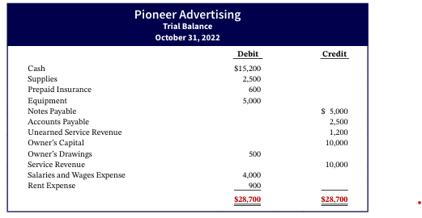

**Exercise**

1.From the ledger accounts below, prepare a trial balance for Bundy Company at December 31,2022. List the accounts in the order shown in the text. All account balances are normal.

Accounts Receivable $10,000

Salaries and Wages Expense $ 2,300

Supplies 4,100

Rent Expense 1,200

Accounts Payable 3,500

Owner’s Capital 10,200

Owner’s Drawings 1,100

Cash 6,000

Service Revenue 11,000

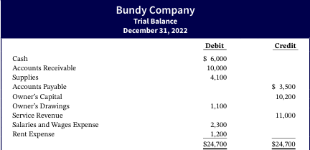

2. **Bob Sample opened the Campus Laundromat on September 1, 2010. During the first month of operations, the following transactions occurred.**

|  |  |
| --- | --- |
| **Sept. 1** | **Bob invested $20,000 cash in the business.** |
| **2** | **The company paid $1,000 cash for store rent for September.** |
| **3** | **Purchased washers and dryers for $25,000, paying $10,000 in cash and signing a $15,000, 6-month, 12% note payable.** |
| **4** | **Paid $1,200 for a one-year accident insurance policy.** |
| **10** | **Received a bill from the Daily News for advertising the opening of the laundromat $200.** |
| **20** | **Bob withdrew $700 cash for personal use.** |
| **30** | **The company determined that cash receipts for laundry services for the month were $6,200.** |

**Instructions**

**a) Journalize the September transactions.**

**b) Open ledger accounts and post the September transactions.**

**c) Prepare a trial balance at September 30, 2010.**

**Solution**

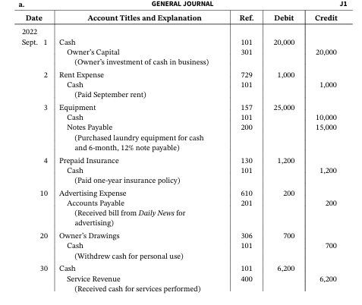

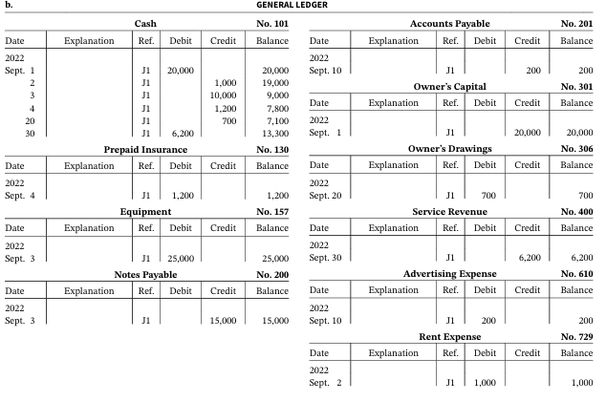

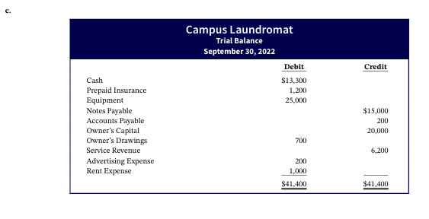

**Home Practice**

**Beyers Corporation provides security services. Selected transactions for Beyers Corporation are presented below:**

|  |  |
| --- | --- |
| **Oct. 1** | **Issued common stock in exchange for $66,000 cash from investors.** |
| **2** | **Hired part-time security consultant. Salary will be $2,000 per month. First day of work will be on October 15.** |
| **4** | **Paid 1 month of rent for building for $2,000.** |
| **7** | **Purchased equipment for $18,000, paying $4,000 cash and the balance on account.** |
| **8** | **Paid $500 for advertising.** |
| **10** | **Received bill for equipment repair cost of $390.** |
| **12** | **Provided security services for event for $3,200 on account.** |
| **16** | **Purchased supplies for $410 on account.** |
| **21** | **Paid balance due from October 7 purchase of equipment.** |
| **24** | **Received and paid utility bill for $148.** |
| **27** | **Received payment from customer for October 12 services performed.** |
| **31** | **Paid employee salaries and wages of $5,100.** |

**Instructions:**

**(a) Journalize the transactions. Do not provide explanations.**

**(b) Post the transactions to T-accounts.**

**(c) Prepare a trial balance at October 31, 2017.**

**Holz Disc Golf Course was opened on March 1 by Ian Holz. The following selected events and transactions occurred during March.**

|  |  |
| --- | --- |
| **Mar. 1** | **Invested $20,000 cash in the business.** |
| **3** | **Purchased Rainbow Golf Land for $15,000 cash. The price consists of land $12,000, shed $2,000, and equipment $1,000. (Make one compound entry.)** |
| **5** | **Paid advertising expenses of $900.** |
| **6** | **Paid cash $600 for a one-year insurance policy.** |
| **10** | **Purchased golf discs and other equipment for $1,050 from Stevenson Company payable in 30 days.** |
| **18** | **Received $1,100 in cash for golf fees (Holz records golf fees as service revenue).** |
| **19** | **Sold 150 coupon books for $10 each. Each book contains 4 coupons that enable the holder to play one round of disc golf.** |
| **25** | **Withdrew $800 cash for personal use.** |
| **30** | **Paid salaries of $250.** |
| **30** | **Paid Stevenson Company in full.** |
| **31** | **Received $2,700 cash for golf fees.** |

**Journalize the March transactions.**